advanced  SNIPER  LONG RANGE & MOVERS  PRESENTED BY: ADVANCED COMBAT EVOLUTIONS  When  May 1-2, 2025  0800-1700  Where  Fresno Rifle & Pistol Club  15687 Auberry Road Clovis, CA 93626  Shooting out to 800 yards – unknown distance engagements – tripod techniques – moving targets to 200 yards – use of force decision making – simulated hostage rescue engagements  To register:  www.advancedcombatevolutions.com or scan QR code in the bottom right corner of this flyer.  Questions? Call (559) 360-0704 | 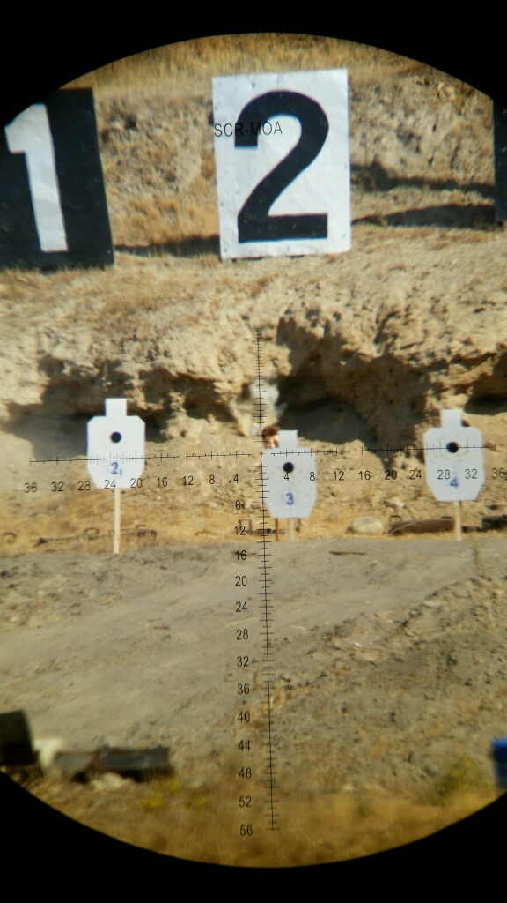  post-certified  course #1361-23070  tuition:  $499.00  2 days  16 hours of POST credit  contact:  (559) 360-0704  For more information  